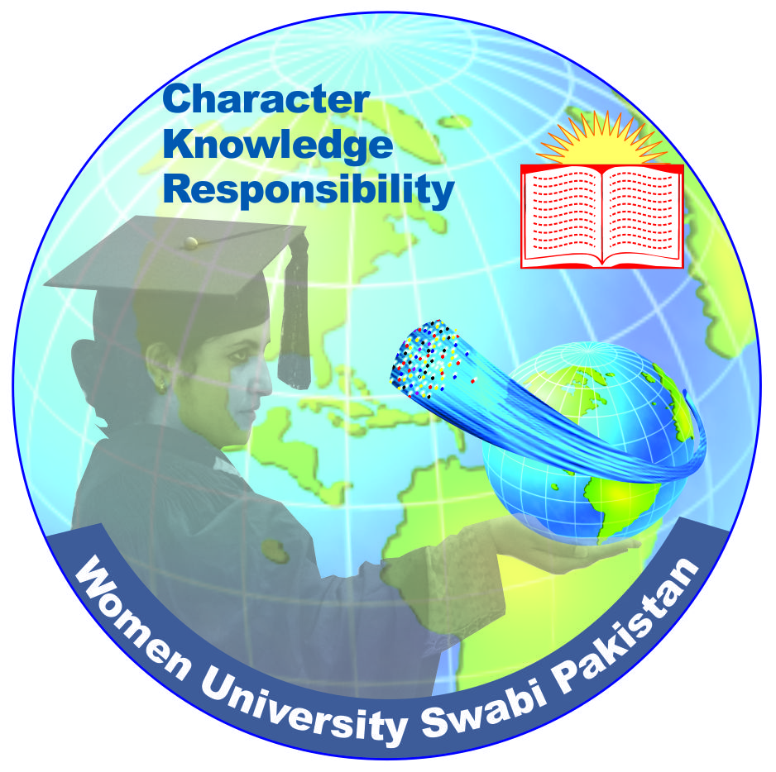
Women University, Swabi

Paste 04 recent passport
size pictures

URL: www.wus.edu.pk

JOB APPLICATION FORM FOR NON-TEACHING POSITIONS

(BPS 17 & ABOVE)

Advertisement No: ________________________
Post Applied for: ________________________

I. Personal Information
1. Name (Block Letters): |  | 2. Father’s Name (Block Letters): |  | 3. CNIC Number:
4. Gender: Male  Female |  | 5. Domicile: |  | 6. Place of Birth:
7. Permanent Address: |  |  | 8. Present/Mailing Address:
9. Date of Birth (day/month/year): | 10. Nationality: |  | 11. Religion: |  | 12: Marital Status:
13. Phone (a) Residential  (b) Official |  |  | 14: Mobile Number:
15. E-mail address: |  |  | 16. Marital Status:

II. Academic Qualification
S# | DEGREE/  CERTIFICATE | Major/  Subjects | Board/ University | Year of Passing | Total Marks | Obtained Marks | Division/ Grade | Percentage
1. | Matriculation
2. | Intermediate
3. | Bachelors  (14 years educ.)  (14 years)  (Hons)
4. | Masters/ BS  (16 years educ.)
5. | M.Phil./MS
6. | PhD
7. | Post Doctorate
8. | Any Other

III. Distinction (Awards/ Medals/Certificates with detail)

IV. Professional Qualification/Training/Certificates/Others;

S# | Title of Training/ Course | Diploma/ Certificate | Field of Study | Institution | Grade / Division
1
2
3
*Attach additional sheet if required
V. Employment Record (Start from current position)
S# | Name of Institute/Organization | Designation | BPS | Nature of Job (Permanent/Temporary/Contract/Fixed Pay) | Job Description | Duration Time
 |  |  |  |  |  | Dates |  | Period
 |  |  |  |  |  | From | To | YY-MM-DD
1 |  |  |  |  |  |  |  | ___-___-___
2 |  |  |  |  |  |  |  | ___-___-___
3 |  |  |  |  |  |  |  | ___-___-___
4 |  |  |  |  |  |  |  | ___-___-___
5 |  |  |  |  |  |  |  | ___-___-___
6 |  |  |  |  |  |  |  | ___-___-___
7 |  |  |  |  |  |  |  | ___-___-___
Total* |  |  |  |  |  | Years:______ Months: _____Days:

*Total Experience till closing date of application. Attach additional sheet if required

VII. Country Visited

Sr # | Name of Country | Duration | Purpose of Visit

VI. Research Publications, if any
(a) National/ International Journal Papers
S# | Name of  Author (s) | Complete Name of  Journal and Address  with ISSN (Print) No. |  | Title of Publication |  | Vol. No.  & Page  No. |  | Category  W/X/Y/Z | Year  Published
1.
2.
3.
4.
5.
(b) National/International Conference Papers

S# | Title of Publication |  | Conference |  | Date |  | Venue
1
2
3
4.
5.

*Attach additional sheet if required

VIII. References (Academic/Professional)
Reference-1 | Reference-2

IX- Bank Draft / Receipt No.:__________________________________________ (Please attach in original)

Amount in PKR: ________ __________________________________ Date: _________________________________

Declaration:
It is hereby certified that information given in this application form is correct and nothing relevant has been concealed.

Date: ______/_______/________ ______________________________
Signature of Applicant

X- Check-List of testimonials attached:

- N.I.C
- SSC (DMC/Transcript + Certificate)
- FA/F.Sc (DMC/Transcript +Certificate) | Please Send Application Form to:  Deputy Registrar  Women University, Swabi  Gulo Dehri, Topi-Road, Swabi  Khyber Pakhtunkhwa, Pakistan  Phone No. 0938-221193
- BA/BSc (DMC/Transcript + Degree)
- MS/MSc/BS (Transcript +Degree)
- M.Phil/MS (Transcript +Degree)
- PhD (Transcript + Degree)
- List of Publications/ Research Papers
- Experience Certificate(s)
- NOC (for In-service candidate)
- Other documents:
______________________________
______________________________
______________________________

GENERAL INSTRUCTIONS / INFORMATION:

- Applications must reach to the office of the undersigned on or before 15 November, 2019. Incomplete applications or applications received after the due date will not be considered.

- Please fill the Application Form properly with complete and correct information. DO NOT leave any field blank, otherwise your application may not be considered.

- Incorrect, false or forged information may result in cancellation of your candidature at any stage, even after employment, and also proceeding of a legal action.

- Original Receipt of Bank draft/Online deposit, Attested photocopies of all DMCs, degrees, certificates, experience certificates, CNIC, four recent passport size photographs, must be attached with the Application Form.

- Contact number, Postal and Email addresses must be written clearly on the application form. Any change in contact detail must be reported immediately to the Registrar Office.

- Candidates applying for more than one position should submit separate forms with all relevant copies and separate bank draft/receipt

